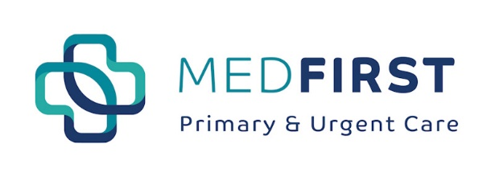

**Early Screening Saves Lives**

**Did you know:**

***Breast cancer is the most commonly diagnosed cancer in women, with one in eight women in the United States diagnosed with breast cancer in her lifetime.***

**CDC and United States Preventative Services Task Force Recommend:**

* The CDC and USPSTF recommends that women who are 50 to 74 years old and are at average risk for breast cancer get a mammogram every two years.
* Women who are 40 to 49 years old should talk to their doctor or other health care professional about when to start and how often to get a mammogram.
* Women, along with their Medical Provider, should weigh the benefits and risks of screening tests when deciding whether to begin getting mammograms before age 50.

**Risk Factors:**

* Not enough exercise
* Obesity
* Alcohol consumption
* Hormone Replacement Therapy (HRT)
* Family history of breast cancer

**What can** Med **First** **do to help you get screened for breast cancer?**

* Our teams of qualified Providers can perform a physical and breast exam as the first step in your screening, at the location that is most convenient for you.
* We can then refer and even help you schedule your mammogram for a time and day that works for you.
* We can help you get on a weight loss and nutrition plan, to help you get healthy.
* We will be diligent in following up with you to review the results of your screening and take any appropriate next steps.

**Let** Med **First help you get your Mammogram scheduled! Find your location here** [**https://www.thinkmedfirst.com/locations/**](https://www.thinkmedfirst.com/locations/)**, request an appointment online to talk to your Provider here** [**https://www.thinkmedfirst.com/appointments/**](https://www.thinkmedfirst.com/appointments/)**or walk-in today!**